Part 1 – AWS Architecture Design for Real-Time Fraud Detection

✅ 【Step 0 — Administrator & Security Setup】管理员与安全体系（题目明确要求）
0 IAM 身份认证与权限管理（Week 3 Security）

使用 IAM Users + MFA 保护管理员账户
使用 IAM Roles 让服务访问 AWS（例如 EC2 访问 S3/SQS）
使用 Least Privilege 最小权限原则
CloudTrail 记录所有访问（Week 3 提到 “traceability”）
Step 0 — Administrator & Security Setup
The fraud detection environment is governed by IAM-based administrative controls within a multi-account structure managed through AWS Organizations.
The analytics team is granted full management access through a dedicated IAM group, while all compute components (Lambda/EC2 Workers) use least-privilege IAM roles.
All sensitive data is protected using SSE-KMS encryption, and CloudTrail is enabled at the Organization level to capture immutable audit logs in a centralized logging account. MFA is enforced for privileged accounts, ensuring strict access control consistent with financial-industry security requirements.
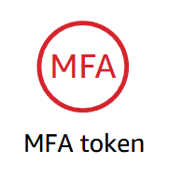
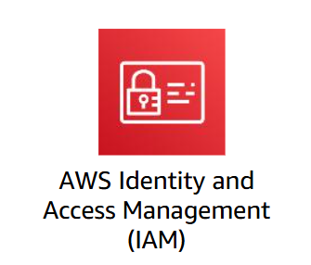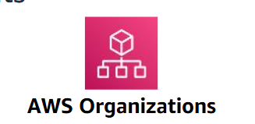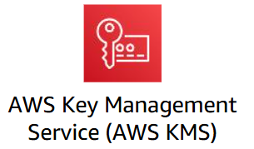

📌 这覆盖了题目的要求：
“only authorized team members may access the application and related data”
✅ 【Step 1 — Secure Transaction Ingestion】数据如何进入系统
SQS + 安全网络通道 + IAM/KMS
- Amazon SQS Standard Queue：SQS 作为队列接收所有实时交易事件；提供 decoupling / buffering / retry / high throughput
- VPC + 安全连通方式（VPN / Direct Connect）：保障银行私有云到 AWS 区域的网络是加密、受控的
- IAM & KMS（SSE-KMS for SQS）：控制谁能向 SQS 写入消息（只允许银行端系统），加密队列中的敏感金融数据
Real-time transaction data from the bank’s private cloud is ingested directly into AWS through secure, encrypted calls to an Amazon SQS Standard Queue.
The bank’s transaction system uses IAM-protected SQS API access to push each event over an encrypted channel (HTTPS or VPN/Direct Connect), ensuring no data is stored in the private-cloud environment.
SQS provides buffering, decoupling, and high-throughput durability, preventing overload and ensuring continuous operation during traffic spikes or infrastructure failure.
All messages are protected with SSE-KMS encryption to meet financial-data security requirements.
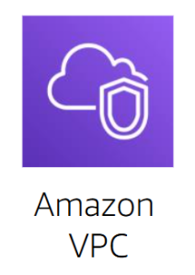

✅ 【Step 2 — Fraud Detection Processing Layer】交易如何被处理
从 SQS 中取出交易消息 → 调用已训练好的 fraud detection 模型 → 生成 fraud score / decision → 把结果交给后续存储与告警层。
2.1 部署 Fraud Detection Workers
（A）Lambda（同样acceptable）
Zero-maintenance
随 SQS 触发自动扩容
快速、成本低
（B）EC2 + Auto Scaling Group（主）
运行 fraud detection 应用和模型推理代码，根据负载自动增加 / 减少 worker 实例（高可用 + 弹性）

2.2 Worker 连接 SQS：消费交易消息

2.3从 S3 加载模型 & 支持版本更新（关键点）

Fraud Detection Workers consume transaction messages from the SQS queue and perform real-time model inference.
An EC2 Auto Scaling Group, built from a unified Launch Template, ensures reliable and cost-efficient processing by automatically scaling across multiple Availability Zones based on SQS backlog.
Each worker loads the current production model from an encrypted S3 model bucket, allowing seamless model version updates without service interruption.
Workers operate using least-privilege IAM roles, securely retrieve data, and forward prediction outputs to downstream storage and alerting components.

✅ 【Step 3 — Detection Output Storage & History】欺诈结果如何存储，历史数据保存在哪里
我们设计如下多层存储：
⭐ 3.1 DynamoDB — 实时预测结果存储（低延迟）
DynamoDB = NoSQL, key-value, 高速、低延迟、可水平扩展。
不需要 schema migration，方便未来扩展字段。
实时查询速度极快（毫秒级），适合 fraud investigation dashboard。
⭐ 3.2 S3 — 长期历史记录（不可变审计数据）
Week 5 的 S3 模块说明：
S3 适用于 large datasets & long-term storage
支持 encryption, versioning
用途：
保存原始交易
保存预测日志
供分析团队使用
⭐ 3.3 RDS（可选）— 团队查询与关联分析
当 analytics team 需要传统 SQL、joins、批量分析时
当需要生成 PDF/Excel 报表或对历史进行更透彻的业务分析
适合作为 “analytical query layer”

Fraud detection outputs are stored using a two-layer design that supports both real-time access and long-term auditability.
Prediction results, including transaction ID, score, decision, and model version, are written to an encrypted DynamoDB table to provide low-latency lookups for the analytics team.
All detection events and triggered actions are additionally archived in an SSE-KMS–encrypted S3 bucket with versioning and lifecycle policies, ensuring durable, immutable audit records.
Optionally, aggregated results can be loaded into RDS for SQL-based analysis and reporting.
✅ 【Step 4 — Alerts & Messaging】异常交易的通知机制
一旦发现可疑交易或新 fraudulent account，要自动触发警报。
Worker → SNS
SNS → Email / SMS / Webhook / SQS
SQS（Alert Queue）给后续系统消费

When a transaction is classified as high-risk, the Fraud Detection Worker immediately publishes an alert message to an encrypted SNS topic (FraudAlertTopic).
SNS fans out the notification to subscribed channels such as email/SMS for the analytics team, or to a dedicated SQS Alert Queue for downstream case-management workflows, following the same SNS→SQS pattern covered in Week 9.
All alert actions are logged through CloudWatch and CloudTrail, ensuring reliable, low-latency notifications and full auditability consistent with financial-industry compliance requirements.
✅ 【step 5. Monitoring & Observability】（监控与可观测性）
满足题目“确保持续运行、及时监控”的要求。
5.1 CloudWatch Metrics
SQS（交易队列）
EC2 Auto Scaling Group / Worker 实例
Lambda（如果使用 Lambda Worker）
SNS / S3
5.2 CloudWatch Alarms
5.3 CloudTrail
5.4 SNS
System health and operational integrity are maintained through CloudWatch metrics, logs, and alarms.
Key indicators—such as SQS backlog, EC2 CPU utilization, worker error rates, and message age—are continuously monitored, with alarms triggering automatic scaling actions or notifications via SNS.
CloudWatch Logs capture inference activity and processing errors for debugging and compliance, while CloudTrail records all API-level changes across S3, SQS, SNS, IAM, and scaling components.
This monitoring layer ensures early detection of issues, supports automated recovery, and provides full auditability for financial-regulatory requirements.
✅ 【Step 6 — Security Controls & Encryption】如何加密、限制访问、保证安全？
6.1使用 IAM 做访问控制（核心要求）
6.2 Encryption
数据存储加密（Encryption at rest）使用 SSE-KMS：
SQS：KMS Queue Encryption
S3 Model Bucket：SSE-KMS
S3 Logs Bucket：SSE-KMS + Versioning
DynamoDB：默认 KMS 加密
RDS（如果用）：启用 storage-level KMS 加密
这保证每一段金融数据都被保护。
6.3 VPC Security
Workers 放在 Private Subnet
通过 VPC Endpoint 访问 S3/SQS
6.4 审计与可追踪性
使用 CloudTrail 记录
Strict security controls are enforced across the fraud detection environment.
Access to S3, SQS, DynamoDB, and SNS is managed through IAM users, groups, and least-privilege instance roles, ensuring only authorized analytics team members can administer the service.
All sensitive data is encrypted using SSE-KMS, while all traffic between the bank’s private cloud and AWS services is protected with TLS.
Workers operate inside private VPC subnets with restrictive security groups, and CloudTrail provides full auditability of model updates, alert triggers, and all administrative actions.
✅ 【Step 7 — High Availability & Fault Tolerance】如何保证不宕机？
题目要求“prevent system breakdowns”。
你可以写：
7.1 Multi-AZ 部署
Worker 层使用 Multi-AZ EC2 Auto Scaling Group
Our Workers follow a pull-based design using SQS, so no load balancer is required.
Instead, SQS distributes work automatically across all available instances.
7.2 Decoupling（SQS）
即使 downstream 宕机，消息不会丢失。
7.3 Auto Scaling
Week 10 描述通过 ALB + ASG 实现高可用。
High availability is achieved by deploying Fraud Detection Workers across multiple Availability Zones within an EC2 Auto Scaling Group.
The ASG continuously replaces unhealthy instances and automatically scales capacity based on SQS backlog metrics monitored through CloudWatch.
This eliminates single points of failure and ensures stable throughput during traffic spikes.
SQS provides durable buffering and retry capability, while S3 and DynamoDB offer inherent multi-AZ data replication.
Together, these mechanisms maintain continuous operation even during infrastructure failures, delivering a reliable and fault-tolerant fraud detection service.
- 保持 VPC Endpoint 框在图上，但将其所有连接都移除（因为它只是一种网络配置，不是数据流中的参与者），只在文字中说明它为 EC2 访问 SQS 和 DynamoDB 提供了私有路径。

